|  |  |  |
| --- | --- | --- |
| Thruput logo red on white | | |
| **Thruput Limited,** 6 Whitworth Road, Marston Trading Estate, Frome, Somerset, BA11 4BY, United Kingdom | | |
| E: support@thruput.co.uk | T: +44 1373 300 818 | W: www.thruput.co.uk |

**Sentinel**

**Technical Supervisor**

**(SNMP)**

**User Manual**

**Note: This is a preliminary draft based upon the existing TSP manual with changes made to reflect the SNMP functionality.**

*The text in Red is preliminary and is for discussion and will be removed in the final version of this document.*

**Questions are in RED on a Yellow background.**

**DRAFT**

This document is the copyright of the Thruput Limited. No material may be reproduced, copied, translated or modified without the express written permission of Thruput Limited.

Sentineltm, MIDAStm, *The Graphix Factory*tm and TruePixeltm are trademarks of Thruput Limited

Thruput products are fully dvi_logo and **VESA** Compliant.

**Contents**

[1 Setting up 3](#_Toc32410102)

[1.1 Hardware 3](#_Toc32410103)

[1.2 Configuration 3](#_Toc32410104)

[1.3 Installation 3](#_Toc32410105)

[1.3.1 Desktop icons 3](#_Toc32410106)

[1.3.2 Time service 4](#_Toc32410107)

[2 Safety notes and instructions 5](#_Toc32410110)

[2.1 Virus protection 5](#_Toc32410111)

[2.2 After using Audio Monitor 5](#_Toc32410112)

[2.3 After using Live view 5](#_Toc32410113)

[2.4 After RMV and IDX decoding 5](#_Toc32410114)

[2.5 Scheduled maintenance 5](#_Toc32410115)

[3 User Interface 6](#_Toc32410116)

[3.1 Starting the Technical Supervisor 6](#_Toc32410117)

[3.2 Logging in to the SNMP Technical Supervisor 6](#_Toc32410118)

[3.3 The Main Display 7](#_Toc32410119)

[3.3.1 Window Title 7](#_Toc32410120)

[3.3.2 View Events Button 8](#_Toc32410121)

[3.3.3 Change Logged in User 9](#_Toc32410122)

[3.3.4 Acknowledge All Events Button 10](#_Toc32410123)

[3.4 Active stations list 12](#_Toc32410124)

[3.5 Changing the default node colours 12](#_Toc32410125)

[3.6 Mimic display 13](#_Toc32410126)

[3.7 List of messages *( I have not checked any of these from the original document)* 15](#_Toc32410127)

[3.7.1 Information messages 15](#_Toc32410128)

[3.7.2 Warning messages 19](#_Toc32410129)

[3.7.3 Error messages 20](#_Toc32410130)

# Setting up

The Technical Supervisor Position has two roles in the Sentinel installation:

1. Provides a real-time overview of the entire System status.
2. Provides engineering with diagnostics and support tools.

## Hardware

The Technical Supervisor comprises a Windows application, running on a PC or server with 1000baseT network links to all installed NAS recorders in the Sentinel system.

## Configuration

Prior to installing the **Sentinel** Technical Supervisor it is recommended that the **Sentinel SNMP** Technical Supervisor Configuration Manual is read .

## Installation

After loading the installation disc, double click **Sentinel** Technical Supervisor and follow the on screen instructions to install.

The Technical Supervisor is a private service that provides a graphical interface to the data polled from all stations using SNMP (Simple Network Management Protocol) and hardware components that are held in the log files of the NAS recorders. The technical supervisor enables the user to drill down into this data as required.

### Desktop icons

As part of the installation, an icon for the Technical Supervisor is automatically generated.

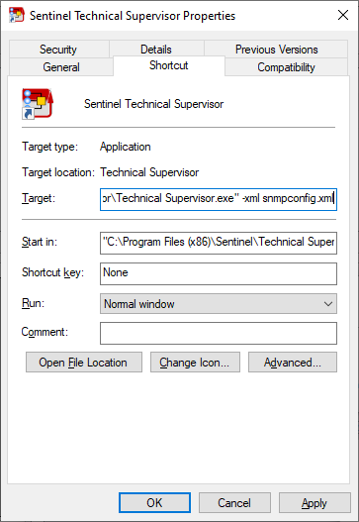

Clicking the right mouse button on the Icon will display

it’s properties:

Ensure that the command line options in the Target field

are set as required.

For SNMP operation it is likely that the addition to the

command line will be similar to either:

-snmp –v3

Or if using a configuration file:

-xml snmpconfig.xml

Where the contents of file snmpconfig.xml would be

similar to:

<thruput>

<tsp>

<usesnmp>Y</usesnmp>

<snmpv3only>Y</snmpv3only>

</tsp>

</thruput>

### Time service

The TSP, and all other servers on the Sentinel network require an NTP time service to ensure correct synchronization between data types and channels.

# Safety notes and instructions

The following instructions must be followed to ensure correct operation of the Sentinel System.

## Virus protection

The Sentinel system is a private data network. The user must observe the following precautions:

1. Never connect any part of the Sentinel system directly to the Internet or to an email or texting service of any kind unless a comprehensive external anti-malware anti-phishing and anti-virus is fully operational.
2. Never load any software or data files from a USB memory stick or portable hard drive.

## After using Audio Monitor

After listening to the live recording from any audio channel on any recorder, always ensure the service is closed before leaving the recorder. This is important because it ensures the network traffic loads are minimized, as high loads may impair the system performance.

## After using Live view

After viewing the live recording from any channel on any recorder, always ensure the service is closed before leaving the recorder. This is important because it ensures the network traffic loads are minimized, as high loads may impair the system performance.

Please note: Every time a live view is started, it forces the generation of a complete I-frame, which temporarily increases the network load.

## After RMV and IDX decoding

After decoding RMV or IDX files, an additional folder containing the export data, is located in the same folder location as the original data. It is recommended that these additional folders are either deleted or removed from the archives in order not to consume storage capacity.

Please note, these additional files automatically overwritten at the end of the archive period.

## Scheduled maintenance

In order to reduce the number of warnings and alerts, it is recommended that maintenance of the system is always scheduled using the tools described below.

# User Interface

## Starting the Technical Supervisor

Start the Technical Supervisor from the desktop icon as shown below:



1. Start up of the TECHNICAL SUPERVISOR.

Before

The Technical Supervisor starts up in dedicated window, and may be used full or part screen. TSP will continue running until stopped.

The Technical Supervisor display shows the active stations list, which indicates the current status of each station, and enables the user to view current status messages.

## Logging in to the SNMP Technical Supervisor

Before trying to log into the SNMP Technical Supervisor ensure that the connected NAS servers hosting the recorders are operational.

The following log in screen will be display when the Technical Supervisor starts:

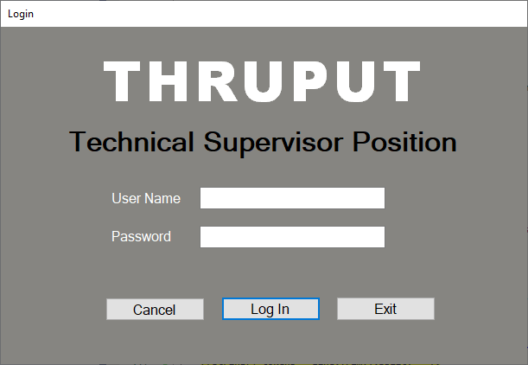

Enter a valid user name and password. The user name and password will be checked with the connected NAS servers and if they are correct the dialog will be closed and the active stations will be displayed. If the user name and password is not accepted by any of the connected NAS servers then an error message will be displayed.

*NOTE: The ‘Cancel’ button allows the login to be bypassed just for development purposes and will be hidden in the final production version. If the Cancel button is hit then the Mimic display will be shown but no events will be collected from the NAS servers as no user will be logged in.*

## The Main Display

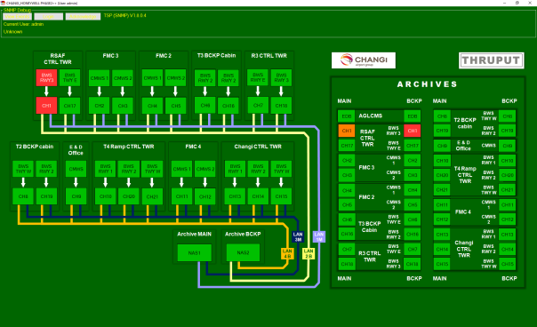

*The main screen operates in the same way as the non-SNMP version with the addition of a ‘SNMP Debug’ box at the top which should help during the testing and development of the SNMP Technical Supervisor. It is not intended to the leave the ‘SNMP Debug’ box on the screen in the final production version.*

*There are three buttons in the ‘SNMP Debug’ box, they are:*

*View Events – which shows the unacknowledged events collected from the NAS servers.*

*Login – To Test the Login window*

*Acknowledge – To Test the Acknowledge All Events functionality*

*All of these buttons have now been integrated in to the Main menu.*

*Some additional debug information showing the progress of collecting events and the logged in user name and role is also shown in the SNMP Debug box.*

### Window Title

The name of the installation and the name of the logged in user will be displayed in the title bar of the main window.



### View Events Button

The unacknowledged events being received by the Technical Supervisor may be viewed by selecting Manage TSP from the main menu and then click on the ‘View Events’ button.

*Is this button in the correct place ?*

*Do we want to allow the user to view the events ?*

*Perhaps only certain users – eg Administrators – should be able view the events ?*

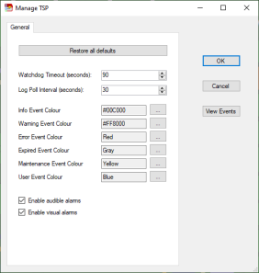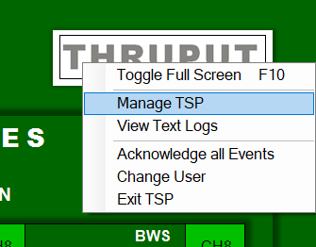

The following dialog will be displayed:

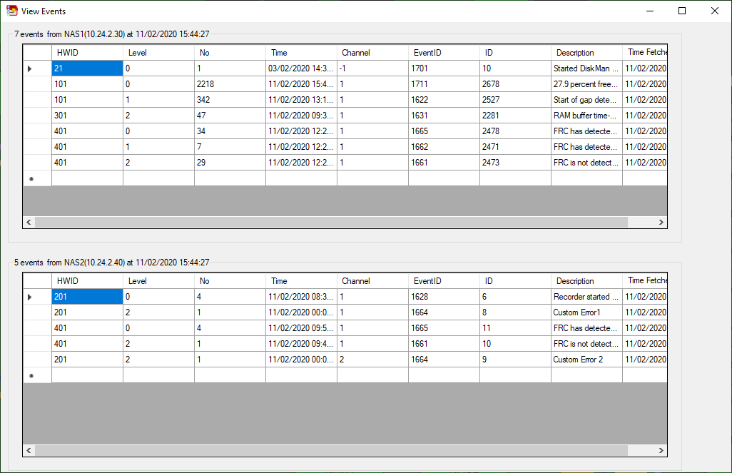

*If we do display these events to user – should we provide more information to make these events easier to understand i.e. display the event description and the name of the hardware item?*

*NOTE: This window can also be accessed by clicking on the View Events button in SNMP Debug box.*

### Change Logged in User

In order to change the logged in user select the ‘Change User’ option from the main menu.

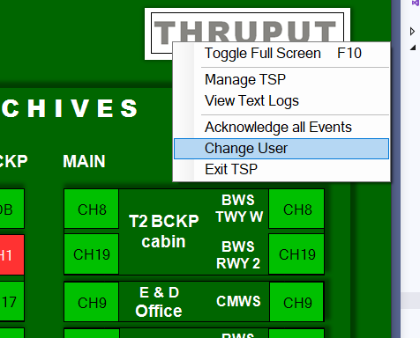

The following login dialog will be displayed:

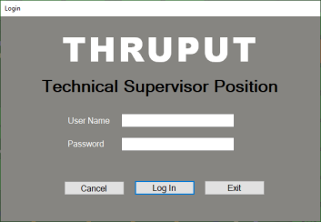

Enter a valid user name and password. The user name and password will be checked with the connected NAS servers and if they are correct the dialog will be closed and the active stations will be displayed. If the user name and password is not accepted by any of the connected NAS servers then an error message will be displayed.

The ‘Log In’ button will be enabled once a user name has been entered and a password of least 8 characters has been entered.

Clicking on the Cancel button will close the login dialog and return the user to the main screen without changing the user. However this will only be available if there has not been an attempt to change the currently logged in user.

Clicking on the Exit button will close down the SNMP Technical Supervisor.

*The ‘Login’ and ‘Change User’ functionality can be tested by clicking on the ‘Login’ button in the SNMP Debug box.*

### Acknowledge All Events Button

The ‘Acknowledge All Events’ dialog can be selected from the main menu.

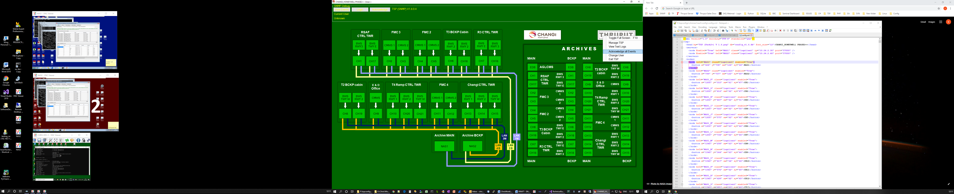

The ‘Acknowledge All Events’ dialog will be displayed:

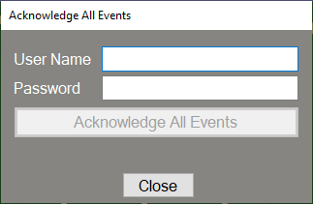

In order to acknowledge all of the events the user name and the password of an administrator must be entered. The ‘Acknowledge All Events’ button will be enabled once a user name has been entered and a password of least 8 characters has been entered.

*The ‘Acknowledge All Events’’ functionality can be tested by clicking on the ‘Acknowledge’ button in the SNMP Debug box.*

*Note that currently it takes a while for the acknowledged events to update the TSP display.I will look into speeding this up.*

If a valid administrator user name and password is entered the following message will be displayed :

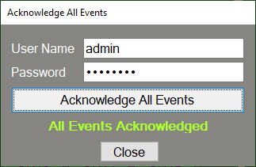

If the user name and password could not be verified then the following message will be displayed.

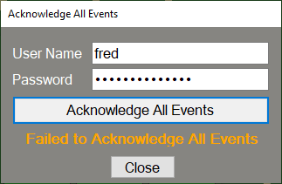

## Active stations list

The active stations list provides a visual indication for all data channels and components in the system, using a mimic display of the installation.

The system is designed to operate unattended, and will generally return to normal operation after conditions that give rise to error states have been cleared. For example, the system will continue to record throughout the re-start cycle of a client’s CWP.

Each node of the active stations list is colour coded as follows:

| **Default Colour** | **Meaning** | **Recommended action** |
| --- | --- | --- |
| **Green** | Operational | None |
| **Amber** | Operational, with warnings update | Review warnings, schedule maintenance if required. |
| **Red** | Operational, with error conditions | Review errors, schedule maintenance. |
| **Grey** | Offline | Start up system and maintenance mode |

## Changing the default node colours

|  |  |
| --- | --- |
| Place the mouse over the THRUPUT or Customer icons on the TSP display and single left click to display the drop down menu. | Logo drop down menu |
| Select ‘Manage TSP’ and then the General tab and amend the colour values as required.  These will be action when the OK button is pressed (single left click). | Manage TSP menu |

## Mimic display

A typical mimic display is shown below:



1. Mimic display (inactive)

By performing a left click on any node, its current message report is revealed as shown below:

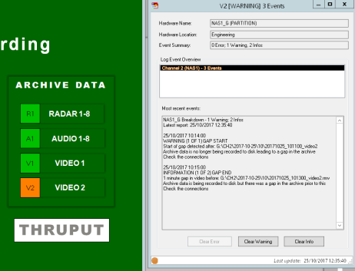

Message report

## List of messages *( I have not checked any of these from the original document)*

The list of messages available in the system is presented below, organised in order of severity into Information, warning and error messages.

Within each message class, the Short names (which is revealed when hovering over an icon) are arranged in alphabetical order.

### Information messages

| **Severity** | **Short\_Name** | **Reporter** | **Event Source** | **Description** | **Action** |
| --- | --- | --- | --- | --- | --- |
| INFO | ALARM\_ACTIVE | AlarmMan | AlarmMan | Alarm is still active | Check event log |
| INFO | ALARM\_CLEARED | AlarmMan | AlarmMan | Alarm has been cleared | None |
| INFO | ALARM\_SET | AlarmMan | AlarmMan | Alarm has been activated | Check event log |
| INFO | CHECKED | DiskMan | DRIVE | The partition has passed all tests. | None |
| INFO | COL\_EVENT | RecMan | SOURCE | Source video colour event detected | None |
| INFO | COL\_EVENT\_1 | RecMan | SOURCE | Colour Event #1 detected | None |
| INFO | COL\_EVENT\_10 | RecMan | SOURCE | Colour Event #10 detected | None |
| INFO | COL\_EVENT\_11 | RecMan | SOURCE | Colour Event #11 detected | None |
| INFO | COL\_EVENT\_12 | RecMan | SOURCE | Colour Event #12 detected | None |
| INFO | COL\_EVENT\_13 | RecMan | SOURCE | Colour Event #13 detected | None |
| INFO | COL\_EVENT\_14 | RecMan | SOURCE | Colour Event #14 detected | None |
| INFO | COL\_EVENT\_15 | RecMan | SOURCE | Colour Event #15 detected | None |
| INFO | COL\_EVENT\_16 | RecMan | SOURCE | Colour Event #16 detected | None |
| INFO | COL\_EVENT\_2 | RecMan | SOURCE | Colour Event #2 detected | None |
| INFO | COL\_EVENT\_3 | RecMan | SOURCE | Colour Event #3 detected | None |
| INFO | COL\_EVENT\_4 | RecMan | SOURCE | Colour Event #4 detected | None |
| INFO | COL\_EVENT\_5 | RecMan | SOURCE | Colour Event #5 detected | None |
| INFO | COL\_EVENT\_6 | RecMan | SOURCE | Colour Event #6 detected | None |
| INFO | COL\_EVENT\_7 | RecMan | SOURCE | Colour Event #7 detected | None |
| INFO | COL\_EVENT\_8 | RecMan | SOURCE | Colour Event #8 detected | None |
| INFO | COL\_EVENT\_9 | RecMan | SOURCE | Colour Event #9 detected | None |
| INFO | COMPRESSED\_FOLDER | ArchiveMan | DRIVE | ArchiveMan has compressed a folder | None |
| INFO | CONFIG\_UPDATE | ConfigMon | ConfigMon | Configuration has been automatically updated and/or copied to a remote system | None |
| INFO | DELETED\_FOLDER | DiskMan | DRIVE | DiskMan service successfully deleted folder | None |
| INFO | DISK\_IO\_RECOVERED | RecMan | RecMan | The DiskWrite service has resumed normal operation after a hard disk IO timeout. Data has been lost | Check disk capacity / operation |
| INFO | DISK\_NORMAL | RecMan | DRIVE | DiskWrite service is operating normally | None |
| INFO | DISK\_STARTED | RecMan | RecMan | DiskWrite service has started | None |
| INFO | DISK\_STOPPED | RecMan | RecMan | DiskWrite service has stopped | None |
| INFO | GAP\_END | RecMan | DRIVE | End of gap in video data | None |
| INFO | I\_FRAME | RecMan | SOURCE | Recorder has detected a complete I-Frame. | None |
| INFO | LOG\_STOP | RecMan | DRIVE | Monitoring stopped for application | None |
| INFO | NET\_STARTED | RecMan | RecMan | NetCapture service has started | None |
| INFO | NET\_STOPPED | RecMan | RecMan | NetCapture service has stopped | None |
| INFO | NTP\_ADJUST | NTP | NTP | NTP Daemon has made a minor adjustment to the system clock | None |
| INFO | NTP\_CONNECTION | NTP | NTP | NTP server connection established | None |
| INFO | NTP\_DRIFT | NTP | NTP | Minor difference noted between system clock and reported NTP time | None |
| INFO | REC\_START | RecMan | DRIVE | Recorder is running | None |
| INFO | SERVER\_CONNECTED | ServerMon | ServerMon | ServerMon has established a PING connection | None |
| INFO | SKIPPING\_FOLDER | ArchiveMan | DRIVE | ArchiveMan had no changes to make to the folder | None |
| INFO | SNMP\_HDD\_INSERTED | SnmpMon | SnmpMon | An HDD has been added to the system | Check RAID set |
| INFO | SNMP\_NTP\_UNKNOWN | SnmpMon | SnmpMon | SnmpMon received an unknown message from NTP | Check configuration |
| INFO | SNMP\_RAID\_LOGIN | SnmpMon | SnmpMon | User has logged into RAID controller | None |
| INFO | SNMP\_RAID\_TEST | SnmpMon | SnmpMon | SnmpMon received a test message from RAID | None |
| INFO | SNMP\_RAID\_UNKNOWN | SnmpMon | SnmpMon | SnmpMon received an unknown message from RAID | Check configuration |
| INFO | SNMP\_REBUILD\_COMPLETE | SnmpMon | SnmpMon | RAID has completed rebuilding a HDD | None |
| INFO | SOURCE\_OK | RecMan | SOURCE | Recorder is operating normally | None |
| INFO | SOURCE\_OK\_TRANS | RecMan | SOURCE | Recorder is operating normally | None |
| INFO | STARTED | AlarmMan | AlarmMan | AlarmMan service has started | None |
| INFO | STARTED | ArchiveMan | ArchiveMan | ArchiveMan has started | None |
| INFO | STARTED | ConfigMon | ConfigMon | Config Monitor has started | None |
| INFO | STARTED | DiskMan | DiskMan | DiskMan service has started | None |
| INFO | STARTED | LogClient | LogClient | LogClient started | None |
| INFO | STARTED | LogMon | LogMon | Logger service has started | None |
| INFO | STARTED | LogMon | LogMon | Log Monitor has started | None |
| INFO | STARTED | NTP | NTP | NTP Daemon has started | None |
| INFO | STARTED | RecMan | RecMan | RecMan service has started | None |
| INFO | STARTED | ServerMon | ServerMon | ServerMon has started | None |
| INFO | STARTED | SnmpMon | SnmpMon | SnmpMon stopped | None |
| INFO | STARTED | Watchdog | Watchdog | Watchdog Service has started | None |
| INFO | STOPPED | AlarmMan | AlarmMan | AlarmMan service has stopped | None |
| INFO | STOPPED | ArchiveMan | ArchiveMan | ArchiveMan has finished | None |
| INFO | STOPPED | ConfigMon | ConfigMon | Config Monitor has stopped | None |
| INFO | STOPPED | DiskMan | DiskMan | DiskMan service has stopped | None |
| INFO | STOPPED | LogClient | LogClient | LogClient stopped | None |
| INFO | STOPPED | LogMon | LogMon | Logger service has stopped | None |
| INFO | STOPPED | LogMon | LogMon | Log Monitor has stopped | None |
| INFO | STOPPED | NTP | NTP | NTP Daemon has stopped | None |
| INFO | STOPPED | RecMan | RecMan | RecMan service has stopped | None |
| INFO | STOPPED | ServerMon | ServerMon | ServerMon has stopped | None |
| INFO | STOPPED | SnmpMon | SnmpMon | SnmpMon started | None |
| INFO | STOPPED | Watchdog | Watchdog | Watchdog Service has stopped | None |
| INFO | UNCOMPRESSED\_FOLDER | ArchiveMan | DRIVE | ArchiveMan has uncompressed a folder | None |
| INFO | WATCHDOG\_NORMAL | AlarmMan | AlarmMan | AlarmMan detected Watchdog service | None |

### Warning messages

| **Severity** | **Short\_Name** | **Reporter** | **Event Source** | **Description** | **Action** |
| --- | --- | --- | --- | --- | --- |
| WARN | WATCHDOG | AlarmMan | AlarmMan | AlarmMan service has had a watchdog failure | Software will automatically restart |
| WARN | WATCHDOG\_TIMEOUT | AlarmMan | AlarmMan | AlarmMan did not detect Watchdog service | Check Watchdog status |
| WARN | FILE\_ERROR | ArchiveMan | DRIVE | ArchiveMan has failed to process a file | Data on disk is no affected |
| WARN | WATCHDOG | DiskMan | DiskMan | DiskMan service has had a watchdog failure | Software will automatically restart |
| WARN | WATCHDOG | LogMon | LogMon | Logger service has had a watchdog failure | Software will automatically restart |
| WARN | NTP\_LARGE\_ADJUST | NTP | NTP | NTP Daemon has made a large adjustment to the system clock | Check NTP source as this may indicate a failure within the system |
| WARN | NTP\_LARGE\_DRIFT | NTP | NTP | Large difference between system clock and reported NTP time | System will automatically adjust system clock when delay timer expires |
| WARN | DISK\_BUFFER\_RECOVERY | RecMan | RecMan | DiskWrite service is swapping buffer to disk to avoid data loss | Software will automatically recover |
| WARN | DISK\_WATCHDOG | RecMan | RecMan | DiskWrite service has had a watchdog failure | Software will automatically restart |
| WARN | DROPPED\_FRAME | RecMan | RecMan | DiskWrite service has dropped one or more video frames | Software will automatically recover |
| WARN | GAP\_IN\_PROGRESS | RecMan | DRIVE | Gap in progress in video data |  |
| WARN | GAP\_START | RecMan | DRIVE | Start of gap in video data | Manually copy data from backup recorder |
| WARN | LOG\_LATE\_START | RecMan | DRIVE | Application was detected before it was registration | None |
| WARN | LOW\_COMPRESSION | RecMan | SOURCE | Source video min compression rate exceeded | Check video source |
| WARN | RES\_CHANGE | RecMan | SOURCE | Source video has changed resolution | Check video source |
| WARN | RES\_CHANGE\_OK | RecMan | SOURCE | Record resolution matches detected resolution | None |
| WARN | WATCHDOG | RecMan | RecMan | RecMan service has had a watchdog failure | Software will automatically restart |
| WARN | SNMP\_RAID\_REBUILDING | SnmpMon | SnmpMon | RAID set rebuilding has begun | Wait for RAID set to rebuild. |
| WARN | SNMP\_REBUILD\_RAIDSET | SnmpMon | SnmpMon | RAID set needs rebuilding | None |
| WARN | SNMP\_UNKNOWN | SnmpMon | SnmpMon | SnmpMon has received an unknown event | Update configuration |
| WARN | WATCHDOG | Watchdog | Watchdog | Watchdog Service has detected a service timeout | Software will automatically restart |

### Error messages

| **Severity** | **Short\_Name** | **Reporter** | **Event Source** | **Description** | **Action** |
| --- | --- | --- | --- | --- | --- |
| ERR | MISSING\_FOLDER | ArchiveMan | DRIVE | ArchiveMan did not find any data within the folder. | Check configuration settings |
| ERR | BAD\_IO | ConfigMon | ConfigMon | IO Error accessing database file or folder | Check permissions on file and/or folder |
| ERR | BAD\_CONFIG | DiskMan | DiskMan | Error reading config | Check config |
| ERR | DELETE\_FAILED | DiskMan | DRIVE | DiskMan service was unable to delete folder | Check disk access. When fixed, software will automatically recover |
| ERR | EXCEEDING\_THRESHOLD | DiskMan | DRIVE | Disk free threshold exceeded and nothing to delete | Manually free disk space by archiving old files |
| ERR | MISSING\_FOLDER | DiskMan | DRIVE | DiskMan could not find a folder to maintain | Manually check configuration |
| ERR | LOG\_FAILED | LogClient | LogClient | LogClient has failed to complete action | Check for latest software updates |
| ERR | SMTP\_TIMEOUT | LogMon | LogMon | Unable to access SMTP server | Check SMTP access |
| ERR | BAD\_CONFIG | NTP | NTP | NTP Daemon has an invalid setting | Check configuration |
| ERR | NTP\_TIMEOUT | NTP | NTP | NTP Daemon timed out trying to contact server | Check NTP server and LAN connectivity |
| ERR | DISK\_BUFFER\_OVERFLOW | RecMan | RecMan | Record buffer error detected | Software will automatically restart |
| ERR | DISK\_FRC\_WATCHDOG | RecMan | FRC | Sentinel Recorder has had a watchdog failure | Check Sentinel Recorder and network connections |
| ERR | DISK\_IO\_FAILURE | RecMan | RecMan | DiskWrite service was unable to write video to disk | Check disk access |
| ERR | NET\_WATCHDOG | RecMan | RecMan | NetCapture service has had a watchdog failure | Software will automatically restart |
| ERR | NO\_SOURCE | RecMan | SOURCE | Source video not detected | Check video source |
| ERR | NO\_SOURCE\_TRANS | RecMan | SOURCE | FRC is reporting 1 or more frames has no source. (Diagnostics) | Check video source |
| ERR | REC\_WATCHDOG | RecMan | DRIVE | Recorder watchdog has expired | Software will automatically restart |
| ERR | UNKNOWN\_CHANNEL | RecMan | RecMan | Channel not registered in config | Check config |
| ERR | UNKNOWN\_EVENT | RecMan | RecMan | Received unknown event ID on network | Check config |
| ERR | UNKNOWN\_STATE | RecMan | RecMan | Received unknown state on network | Check NetCapture version |
| ERR | SERVER\_TIMEOUT | ServerMon | ServerMon | ServerMon was unable to PING connection | Check network connectivity |
| ERR | SNMP\_HDD\_REMOVED | SnmpMon | SnmpMon | A HDD has been removed from the system | Check RAID set |
| ERR | SNMP\_LAN\_DISCONNECT | SnmpMon | SnmpMon | SnmpMon has detected NTP has stopped | Software will automatically restart |
| ERR | SNMP\_RAID\_DEVICE\_FAILED | SnmpMon | SnmpMon | An HDD has failed | Replace HDD at earliest opportunity |
| ERR | SNMP\_RAID\_VOLUME\_DEGRADED | SnmpMon | SnmpMon | Volume within RAID set has degraded | Rebuilding has started |
| ERR | SNMP\_RAID\_VOLUME\_FAILED | SnmpMon | SnmpMon | Volume within RAID set has failed | Replace faulty hardware, and rebuild raid set |
| ERR | SNMP\_RAIDSET\_DEGRADED | SnmpMon | SnmpMon | RAID set has been degraded because one or more drives have failed | Replace HDD at earliest opportunity |

|  |  |
| --- | --- |
|  |  |
|  |  |
|  |  |
|  |  |
|  |  |